NAME:
INSTITUTION:
DATE:
Preventative Tips against Self-Medication Errors

- Health safety begins with You!!
- There are four leading adverse events in the patient safety (DHHS, 2010)
- Medical error
- Patient care
- Surgery errors
- Infections
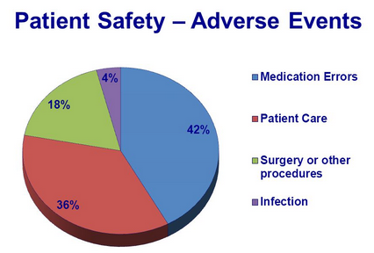

- Notable techniques to prevent medication error at home include;-
- Creating a Culture of Safety
- Promptly report medical errors to facilitate process improvement
- Share information about the problem with caregivers and family members
- Raise awareness about the error to other patients
- Improve the Communication
- Clarity is key toward eliminating medication error
- Communication breakdown contributes significantly to self-medication errors
- Seek for clarification
- Incorporate available Technologies to Prevent Medication Errors
- Set alarms and reminders when the due time approaches
- Never take medicine in darkness
- Participate in Double-checking Important Information during the Administration
- Patients play an important role toward eliminating the adverse effect
- For example, giving accurate personal details that include age or allergic can prevent wrong medications
- Proper Naming, Labeling, and Packaging of the Medicine
- Medicines should be store in a cool dry places and away from the reach of children
- Proper labeling prevent mishap of the drugs. For example, do not store drugs similar drugs in term of color in one box.
- Adequate packaging enhances the quality and efficiency by preventing oxidation due to aerations.
Information to Share with Home Caregivers

- The Effect of Medical Error should not be overlooked.
- The possible causes of medical errors include;-
- Inaccurate recording and transcribing
- Errors in labeling
- Misidentification of patients
- Incomplete delivery of drugs
- Time pressures
- The family member can consult the available intermediate care system in case of an emergency
- These social care facilities collaborate with patients to manage medication
- They have gained traction with patients who have challenges in remembering the appropriate schedule
- Assistive Technology prevents self-medication errors
- for example, automatic drug dispensers and dossette boxes.
- Encourage patient to take active role in their care by encouraging them to speak up
Local Resources Available

- The “SPEAK” Campaign seek to encourage patients to take an active role toward eliminating the adverse events.
- The SPEAK campaign is an initiative by the UC Davis Medical Center
- The U.S Food and Drug Administration provide Education Resources that include drug-related publications
- The FDA further has a tool free-number to address emergency situations
- The national toll-free number is 1-888-INFO-FDA
- The Safe Medication Administration also has a website that contains the best-practices resources to improve safety administration.
- The website also provide free training about the six- rights of to enhance safe health services
References

DHHS. Office of Inspector General. (2018). Adverse events in hospital: National incidence among the Medicare beneficiaries.
Ferrah, N., Lovell, J. J., & Ibrahim, J. E. (2017). Systematic review of the prevalence of medication errors resulting in hospitalization and death of nursing home residents. Journal of the American Geriatrics Society, 65(2), 433-442.
Kalmbach, D. A., Arnedt, J. T., Song, P. X., Guille, C., & Sen, S. (2017). Sleep disturbance and short sleep as risk factors for depression and perceived medical errors in first-year residents. Sleep, 40(3), p.073.
Bogner, M. S. (2018). Human error in medicine. CRC Press.

